Request: To reflect Inbound each line weight variance in (%) at receipt report.

ASR 6386:

Date: 21-10-2016

ISSUE:

Material 78P4785 shortage 50pcs for 10/07 import truck4 ,RDCF#CSS-014-2016 <CHK> Micron PO#3100601370 /Ln1

ASN# 0000087825

**From:** Lee, David   
**Sent:** Thursday, 20 October, 2016 12:59 PM  
**To:** Chan, Pei-Fong  
**Cc:** Mervyn, Tan; He, Jun Shui  
**Subject:** RE: Material 78P4785 shortage 50pcs for 10/07 import truck4 ,RDCF#CSS-014-2016 <CHK> Micron PO#3100601370 /Ln1

Hi Pei Fong,

Is there a possible to reflect each line with the total weight after we entering the supplier packing list weight? Then the system able to calculate weight discrepancy to be cap in within 5%

This calculation 5% is the comparison from our cargo scan machine VS the supplier packing list weight. Please help us on this matter urgently deeply appreciated.

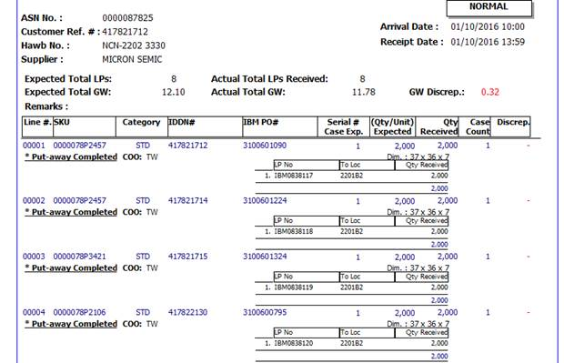

Thank You

Regards

**David Lee**

Supervisor - Operations

Contract Logistics/SCM

Schenker Singapore (Pte) Ltd

17 Changi South St 2, #01-00

Singapore 486129

DID: +65 65491140

HP: +65 87267088

Email: [david.lee@dbschenker.com](mailto:david.lee@dbschenker.com)

Changes;



Var(%)

Gw Rcv.

Gw Exp.

Inbound Creation:

1. Validate gross weight input in detail line.
   1. Validate upon click [Save]

